

**MAIRA EMAAN NASIR**

**BSCS**

**2430-0153**

**PROGRAMMING FUNDAMENTALS**

**LAB 6**

**TASK: 01**

Write a C++ program that will print the following pattern.

**NESTED LOOP**

**CODE:**

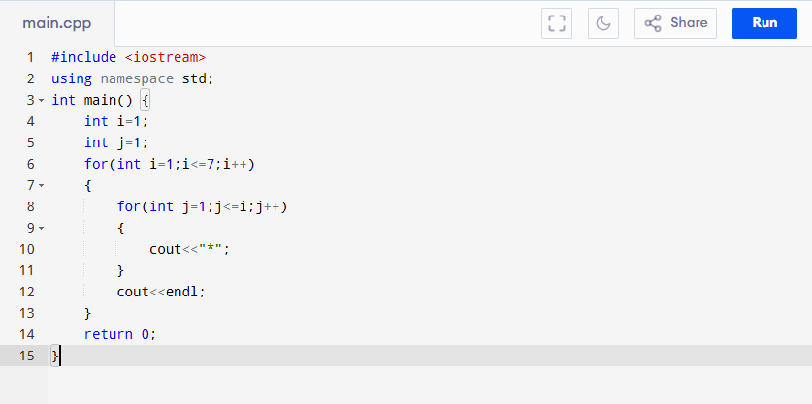

**OUTPUT:**

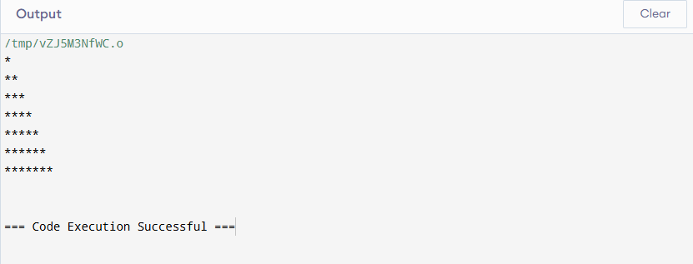

**NESTED WHILE LOOP:**

**CODE:**

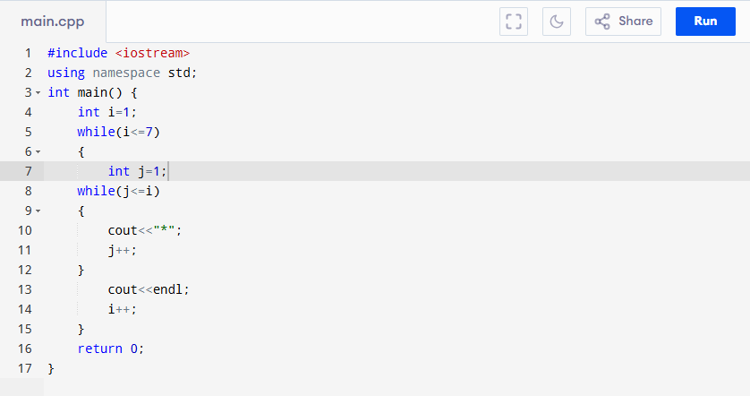

**OUTPUT:**

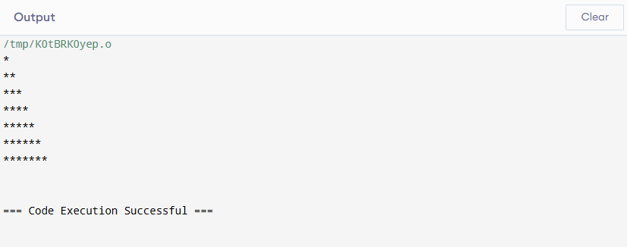

**TASK: 02**

Write a program to print a pyramid pattern with numbers where each row has  
incrementally increasing numbers.

**NESTED LOOP:**

**CODE:**

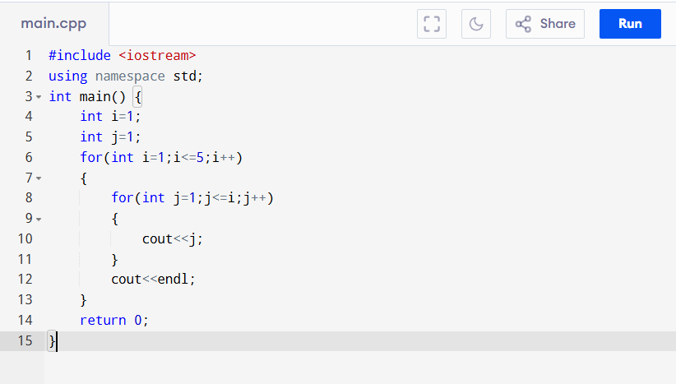

**OUTPUT:**

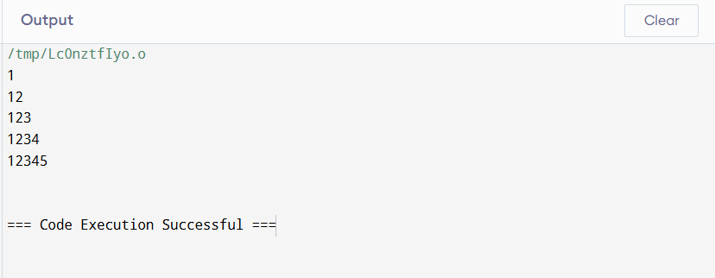

**NESTED WHILE LOOP**

**CODE:**

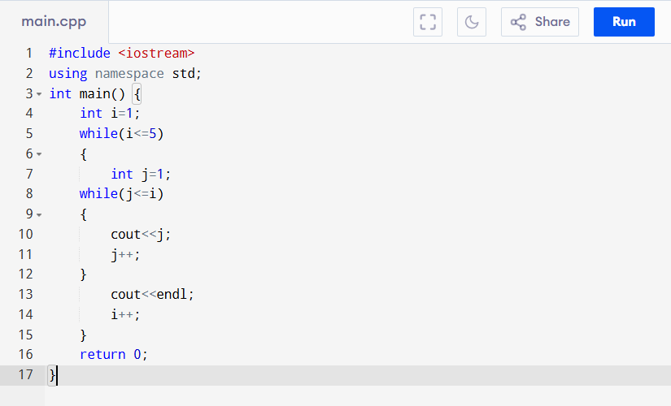

**OUTPUT:**



**TASK: 03**

Write a program in C++ to print a pattern based on a user-input number of rows. The  
pattern should display increasing rows where each row i contains the integer i repeated i times.

**NESTED LOOP:**

**CODE:**

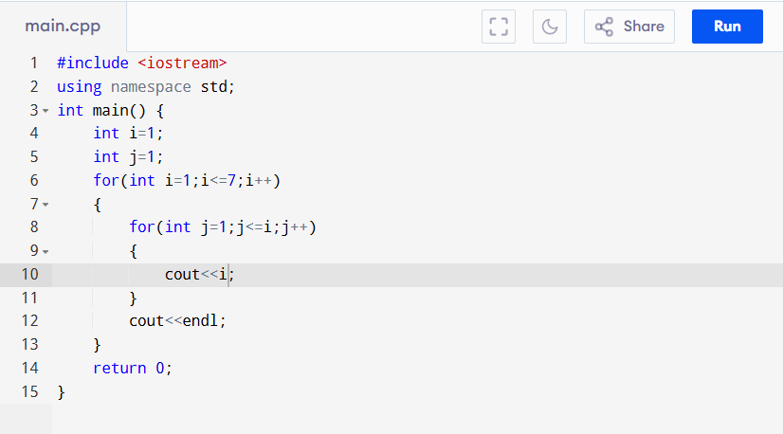

**OUTPUT:**

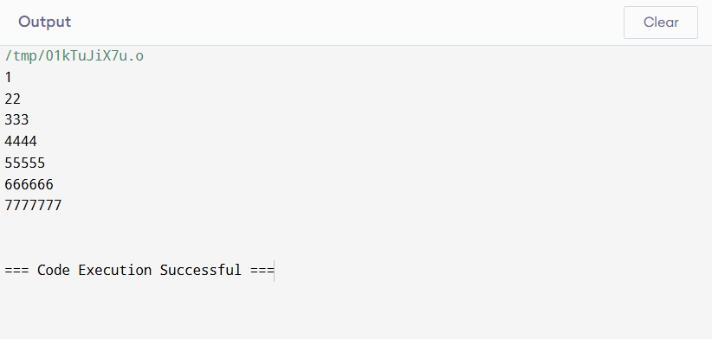

**NESTED WHILE LOOP**

**CODE:**

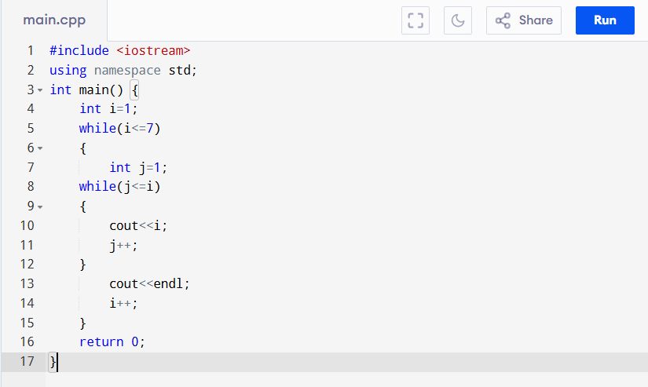

**OUTPUT:**



**TASK: 04**

Create a program that outputs the days for a specified number of weeks. This will help you  
practice using nested loops in C++ and improve your understanding of iteration and output formatting.

**NESTED LOOP**

**CODE:**

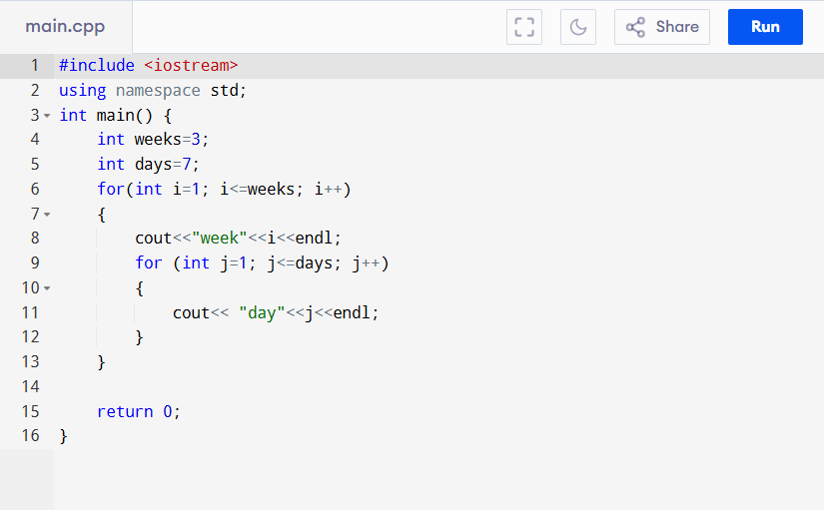

**OUTPUT:**

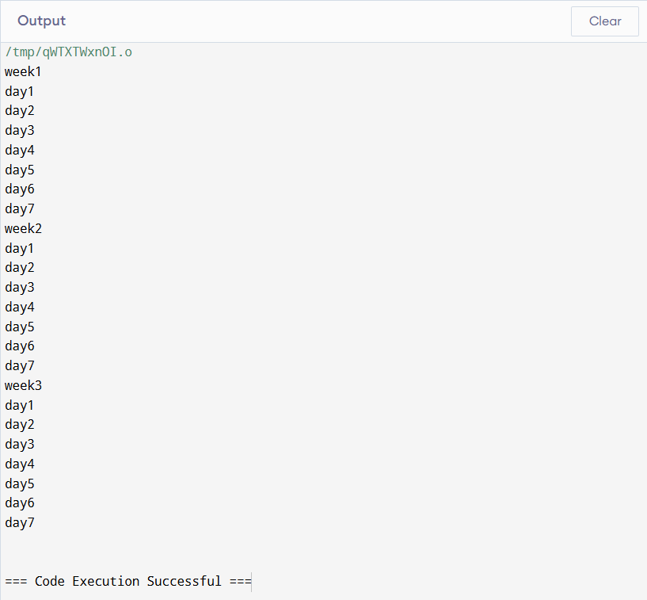

**NESTED WHILE LOOP**

**CODE:**

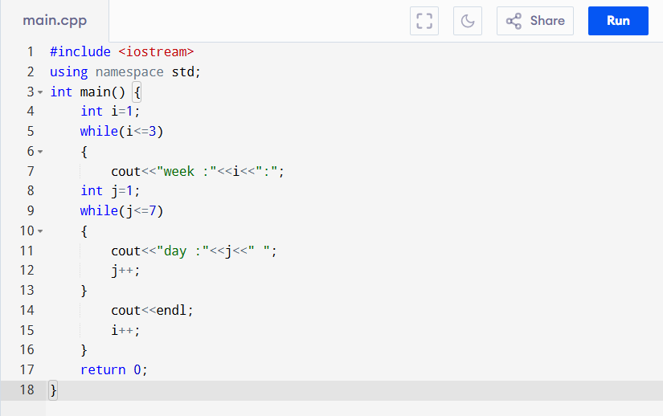

**OUTPUT:**

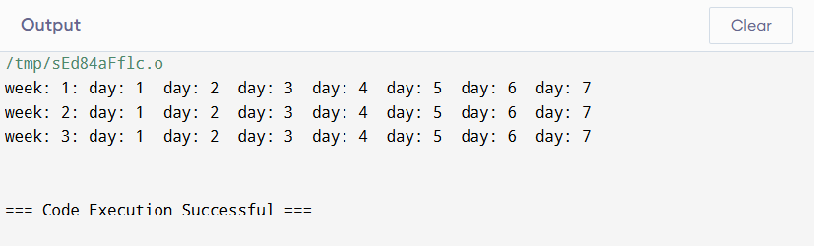

**TASK: 05**

Let’s consider a seating arrangement in a theater. Imagine a theater with multiple rows of seats, where each row has several seats numbered from left to right. If we want to display the seat numbers in each row.

**NESTED LOOP**

**CODE:**

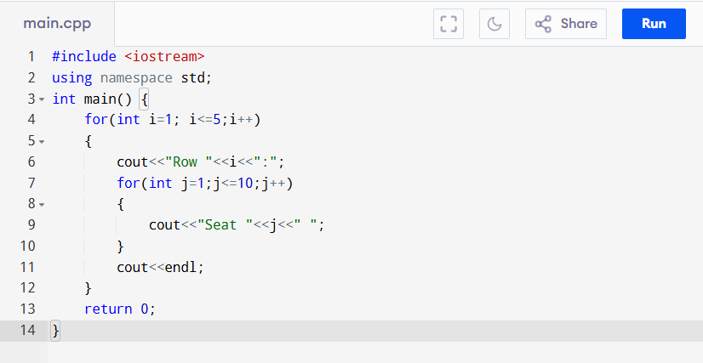

**OUTPUT:**

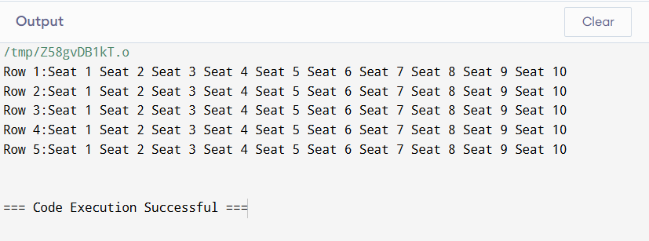

**NESTED WHILE LOOP**

**CODE:**

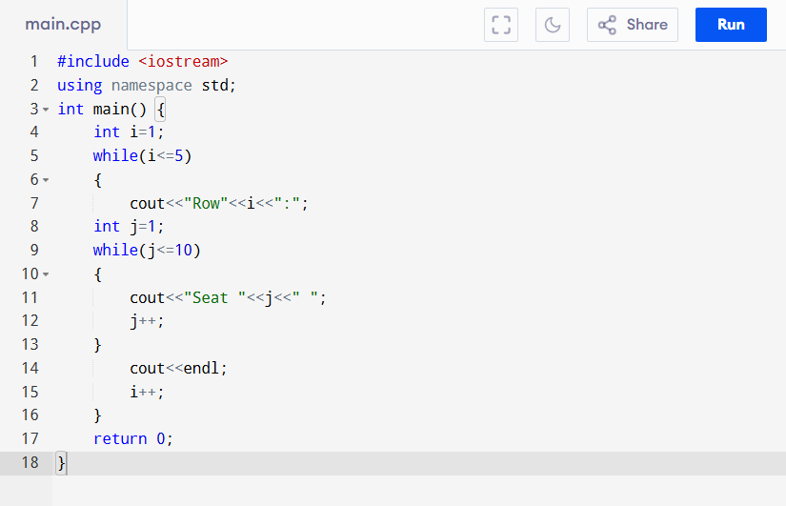

**OUTPUT:**

